**Phase 1: Branding & Business Setup**

**📌 Task:**

1. **Brainstorm and create a business name, tagline, and brand mission.**

**Business Name:**

NeuralNest

**Tagline:**

“Brand the Future.”

1. **Use ChatGPT to generate a compelling brand story that highlights AI-driven branding.**

**Brand Story:**

In a world where attention spans are short and markets evolve overnight, traditional branding no longer cuts it. Startups today need more than design—they need intelligent, adaptive, data-driven brand ecosystems that scale with them.

That’s why we built NeuralNest: a futuristic digital branding agency powered by cutting-edge AI and human creativity. We combine neural networks with design thinking to craft unforgettable identities, smart content, and interactive brand experiences that learn, evolve, and resonate—faster than any agency ever could.

Born at the intersection of design, code, and cognition, NeuralNest isn’t just a service—it’s your startup’s neural backbone for digital identity, market positioning, and emotional resonance. Whether you're seed-stage or scaling, we create brands that speak your vision and think ahead.

At NeuralNest, we don’t just design logos.  
We build living brands for the world of tomorrow.

1. **Use Canva Magic Media to create a unique AI-generated logo.**

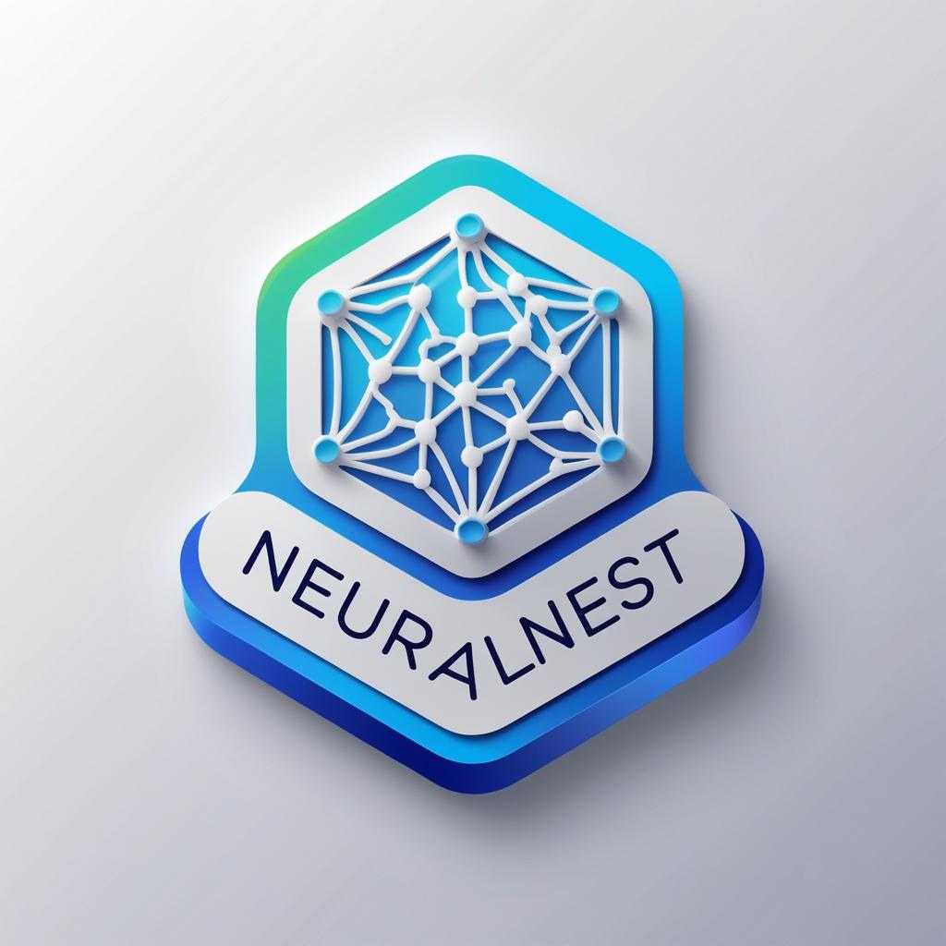

**🔹 Phase 2: AI-Generated Design & Marketing Content**

**📌 Task:**

1. **Social Media Content: Generate AI-enhanced posts and graphics.**

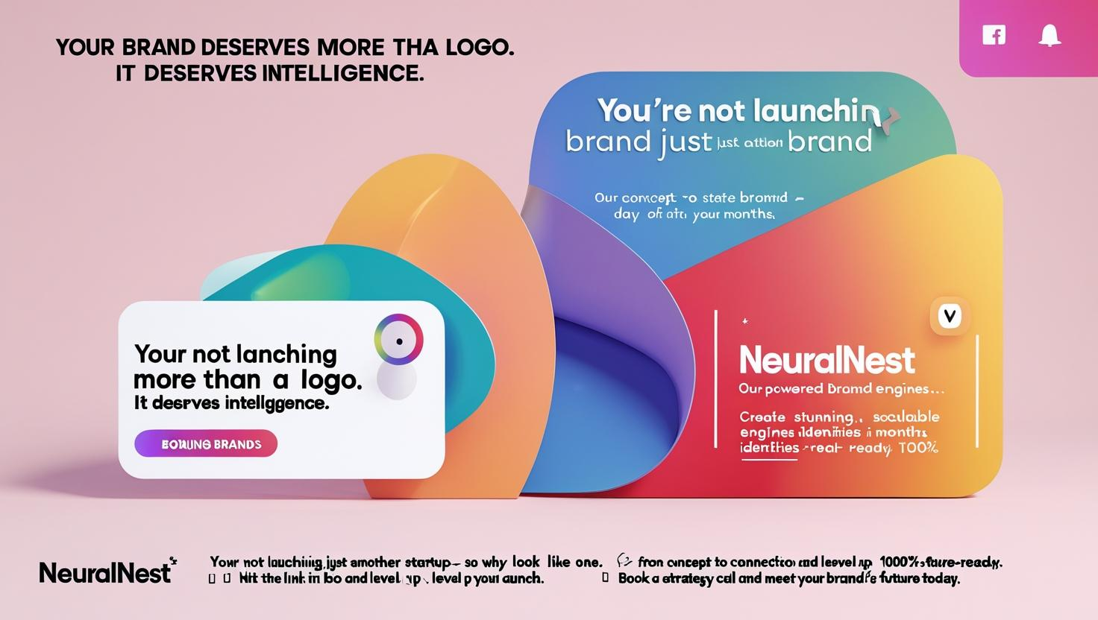

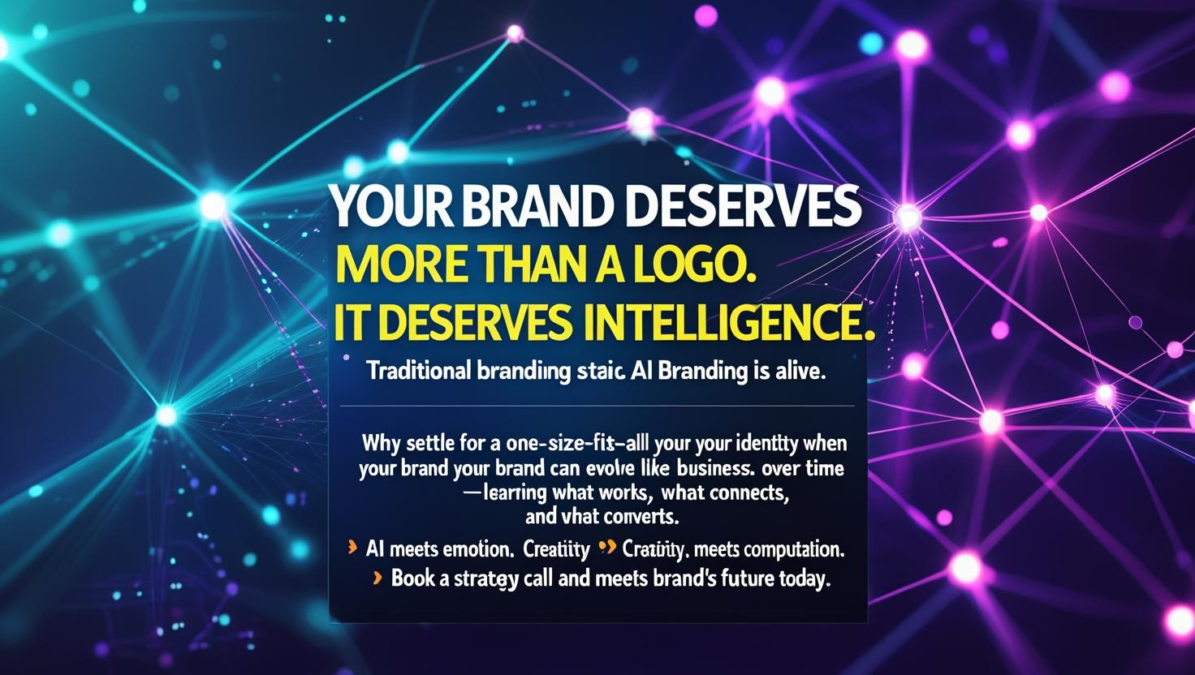

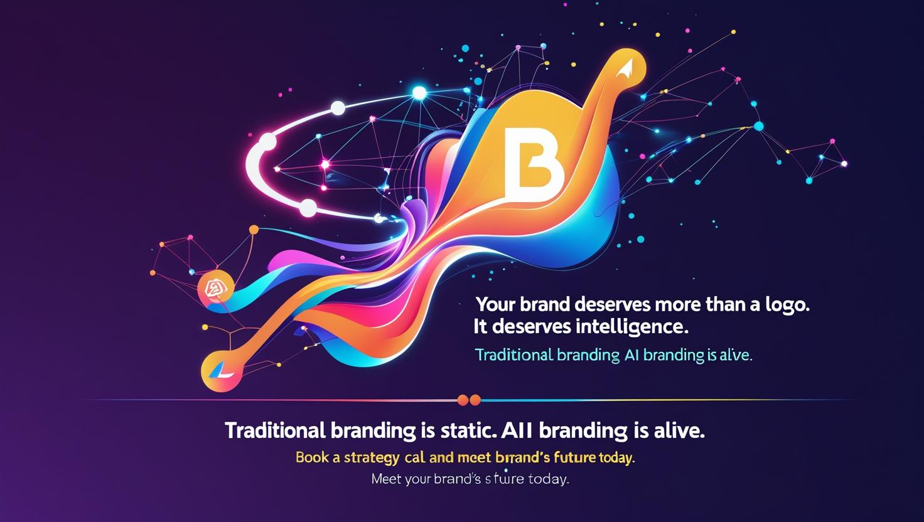

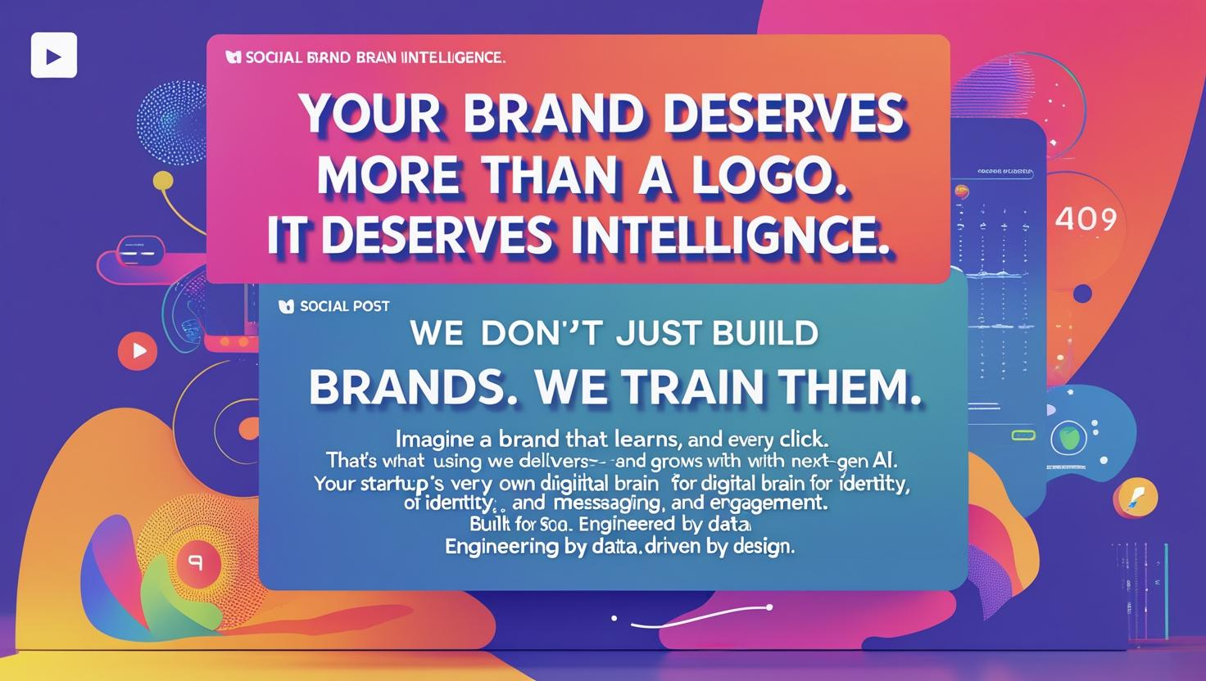

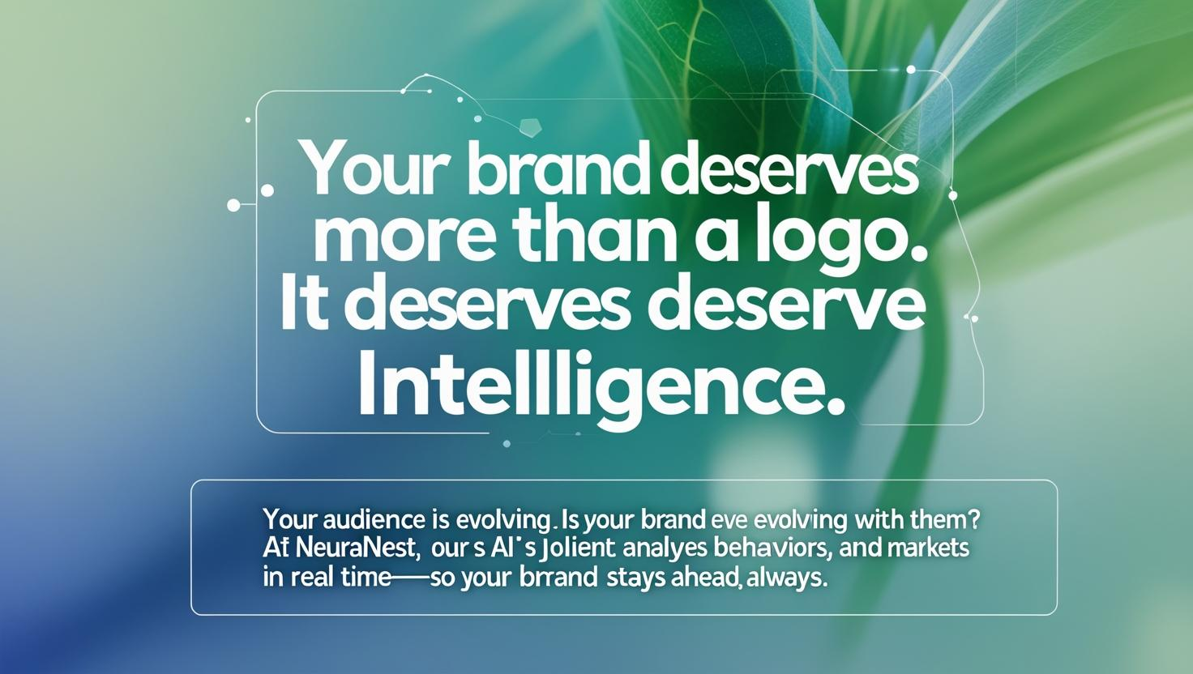

1. **Website Mockups: Use Canva to design sample website layouts.**

**Website Mockup…..**

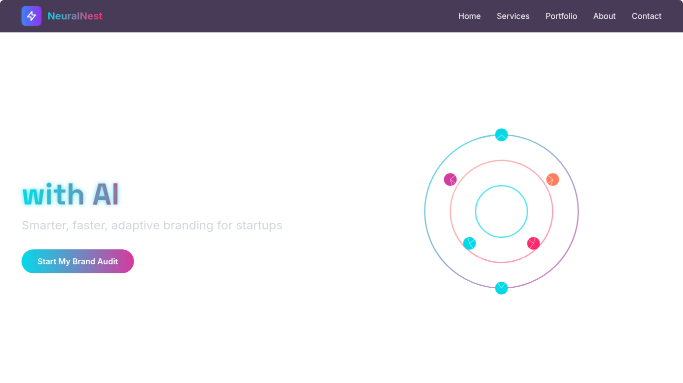

1. **Marketing Copy: Use ChatGPT to write engaging ads, blog posts, and product descriptions.**

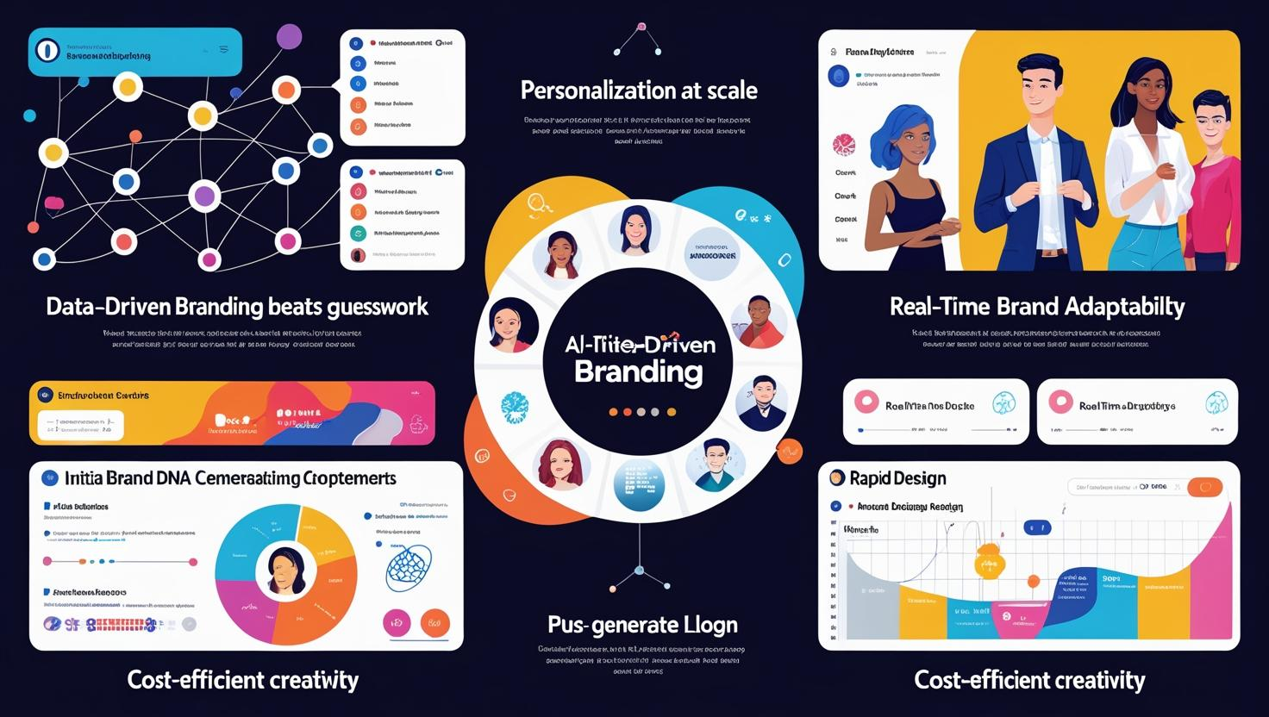

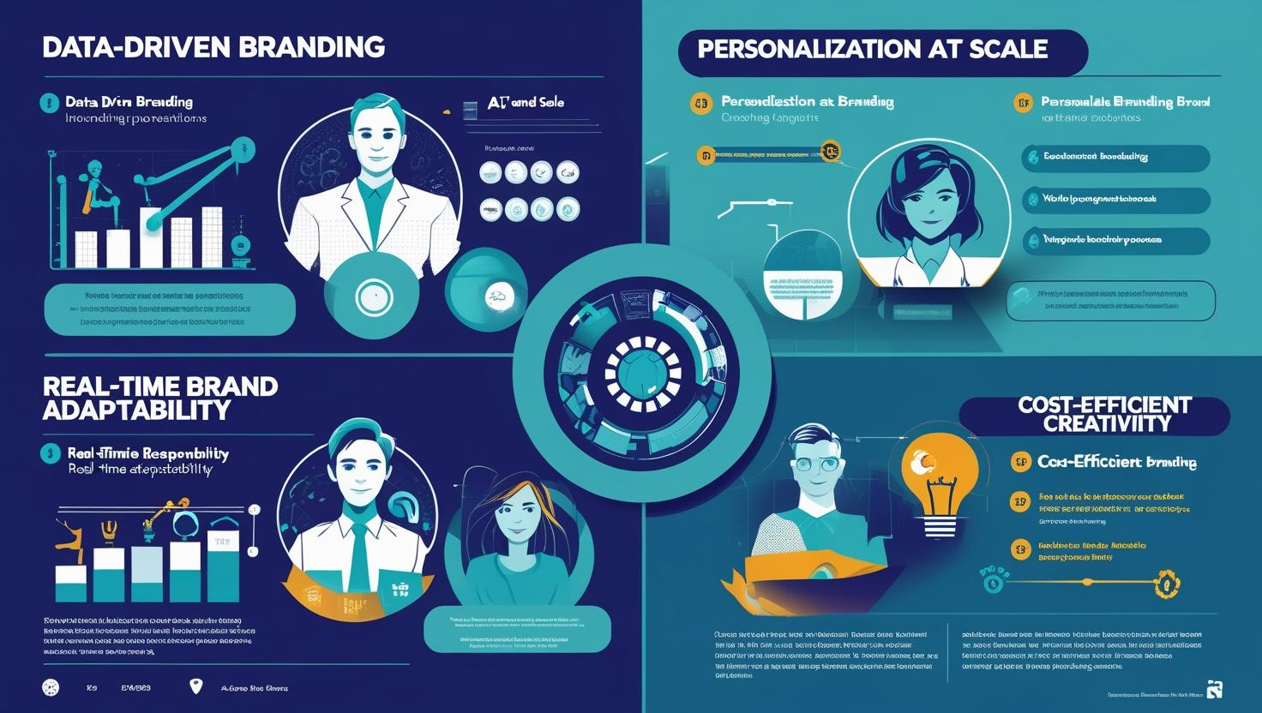

**🔹 Phase 3: Client Outreach & Monetization**

**📌 Task:**

1. **Develop strategies for selling branding assets to clients.**

🔑 1. Sell Outcomes, Not Just Assets

Clients don’t care about a logo—they care about what that logo *does* for their business. Reframe the pitch around:

* Perceived value: “A consistent visual identity increases trust and conversion.”
* Business goals: “Your brand should help you attract the right customers, stand out, and scale.”

🎯 Tip: Package branding assets as *solutions*—not deliverables.

🧠 2. Highlight the Intelligence Behind the Design

As an AI-powered agency, emphasize that your assets aren’t created arbitrarily—they’re:

* Backed by data (customer psychology, market insights, behavioral trends)
* Optimized through machine learning
* Adaptable over time

🧬 Messaging example:

“Our AI doesn’t just design your brand. It learns how your audience thinks and adapts your visuals and tone to match their behavior.”

💼 3. Offer Tiered Packages (with Clear ROI)

Create 2–3 levels of branding packages (Starter / Growth / Scale), each with:

* Assets included (logo, color palette, brand voice, social templates, AI personas)
* Use cases (ideal for startups, rebrands, product launches, etc.)
* Value comparison: show what they save in time, revisions, and creative costs

💰 Pro tip: Include an “AI-driven Brand Performance Dashboard” or “Realtime Brand Insights” as a premium feature to stand out.

📦 4. Productize Your Assets

Package branding components as *products*, so they're easy to buy, understand, and repurpose:

* “The AI Logo Lab” – Instant logo & variations
* “BrandBot Blueprint” – AI-generated brand messaging guide
* “Visual DNA Kit” – Fonts, colors, UI mockups, social templates
* “Smart Launch Pack” – Everything needed for a 30-day brand launch

📁 Make them downloadable, editable, and modular—so clients can use them across platforms.

💬 5. Educate While You Sell

Many clients don’t understand the power of branding. Use:

* Webinars or short videos explaining branding ROI
* Case studies with before/after visuals and metrics
* Interactive tools: e.g., “What’s Your Brand Personality?” quizzes powered by AI

🧲 This turns your sales funnel into a learning experience—and builds trust.

🤝 6. Upsell with Ongoing Optimization Services

AI branding isn’t one-and-done—it evolves. Offer subscriptions or retainer models like:

* Monthly brand health audits
* AI-powered social content generation
* Seasonal rebranding for campaigns
* Performance reports (logo visibility, engagement rates, color sentiment shifts)

📊 This keeps clients coming back—and keeps their brand alive.

🛠️ 7. Show, Don’t Just Tell

Use stunning mockups and dynamic demos:

* AI-generated logo morph animations
* Interactive brand guideline previews
* Before/after rebrand comparisons with real metrics
* Client testimonial videos with on-screen branding

👁️ Visual proof is more persuasive than text—especially in branding.

1. **Use ChatGPT to craft compelling sales pitches and outreach emails.**

**Subject: Future-Proof Your Brand with AI-Powered Creativity 🚀**

Hi Johnson,

I hope this message finds you well. I wanted to reach out with an opportunity that could transform how your brand connects, evolves, and stands out—especially in today’s fast-moving digital world.

At NeuralNest, we combine the precision of artificial intelligence with human creativity to create intelligent, adaptive brand identities that resonate, scale, and convert.

Why consider AI-powered branding?

🔍 Smarter Insights: We use AI to analyze real-time market trends and customer behavior—ensuring your brand always speaks the right language.

🎨 Design That Evolves: Your visual identity won’t just look great; it will learn, adjust, and improve as your business grows.

💬 Hyper-Personalized Messaging: Reach your audience with tailored content that feels personal—at scale.

⏱️ Faster Time to Market: Launch your new or refreshed brand in days, not months—without compromising quality or creativity.

Whether you’re a startup ready to launch or a growing business looking to rebrand, our AI-powered services will help you **build a brand that doesn’t just look good—**it thinks smart.

📈 Let’s Elevate Your Brand

I’d love to show you what’s possible. Let’s schedule a quick strategy call and walk through how NeuralNest can give your brand the competitive edge it deserves.

👉 NeuralNest.co.ke  
Or simply reply to this email—I’m happy to start the conversation.

Looking forward to connecting,  
Neural Nest  
Brand Strategist, NeuralNest  
[neuralnest.ai@gmail.com](mailto:neuralnest.ai@gmail.com)

1. **Design a Canva pitch deck to attract clients for your AI-powered branding service.**

Pitch Deck is located at the another pdf file of presentation right here on this repository in GITHUB….